**Topic: Welfare and Efficiency (Week-5)**

**Question-1**

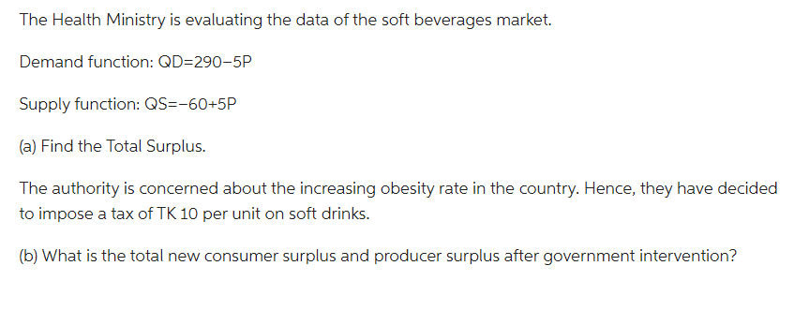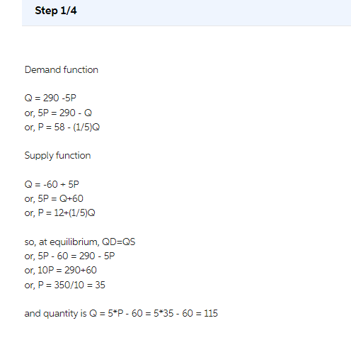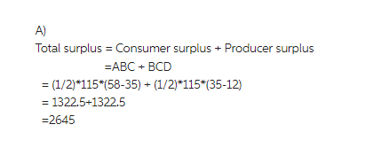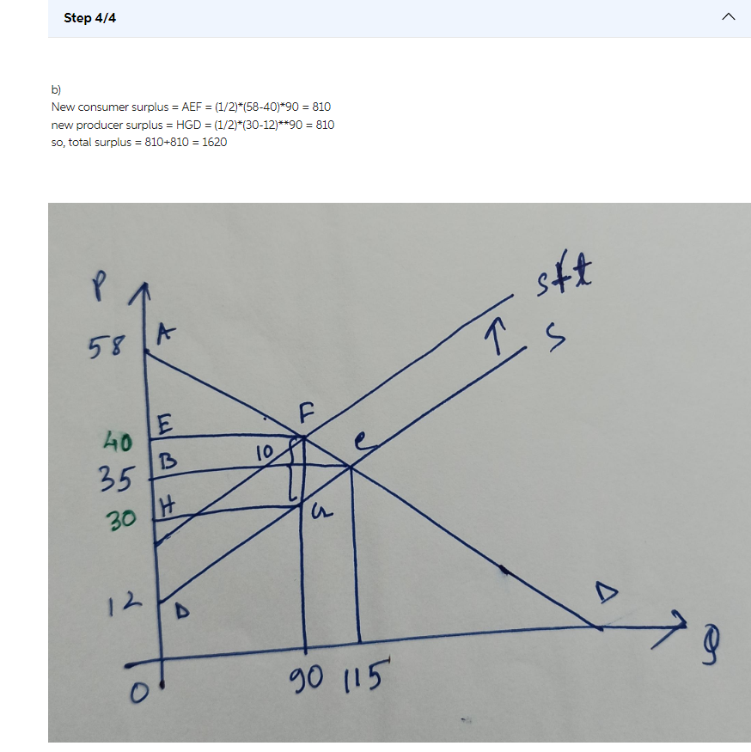

**Question-2**

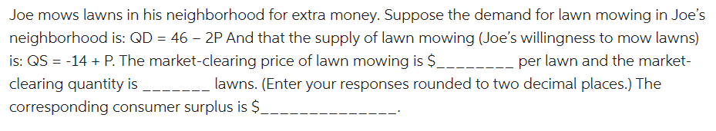

**Solution**

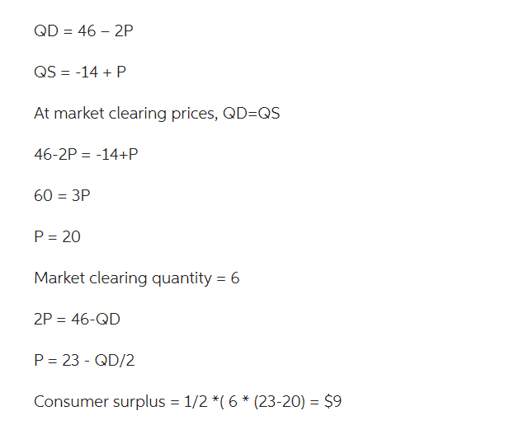

**Question: 3**

**Given the demand and supply equations, find the consumer and producer surplus:**

a) Demand: P=36-0.35X Supply: P=0.05X

**Solution:**

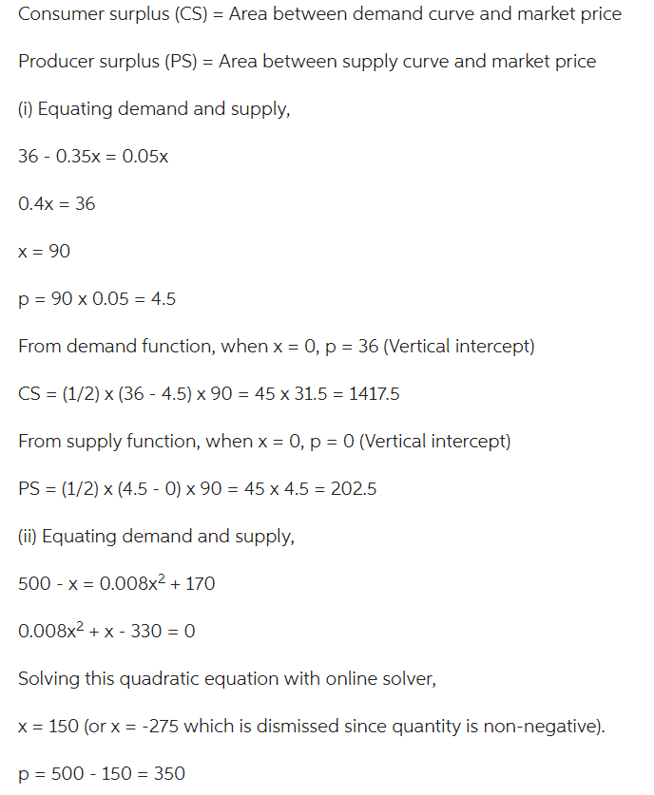

Q: Given the demand and supply equations, find the total surplus ( consumer surplus+producer's surplus).

Qs = 4P-80

Qd = -2P+100

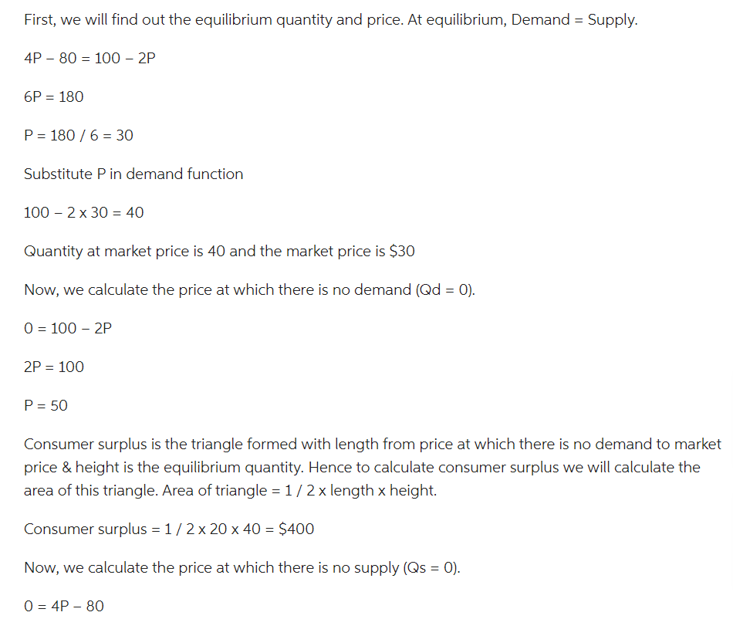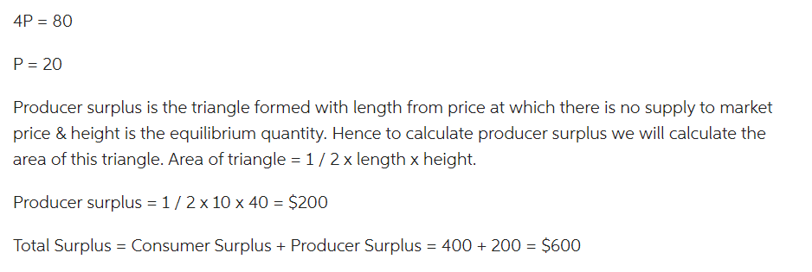

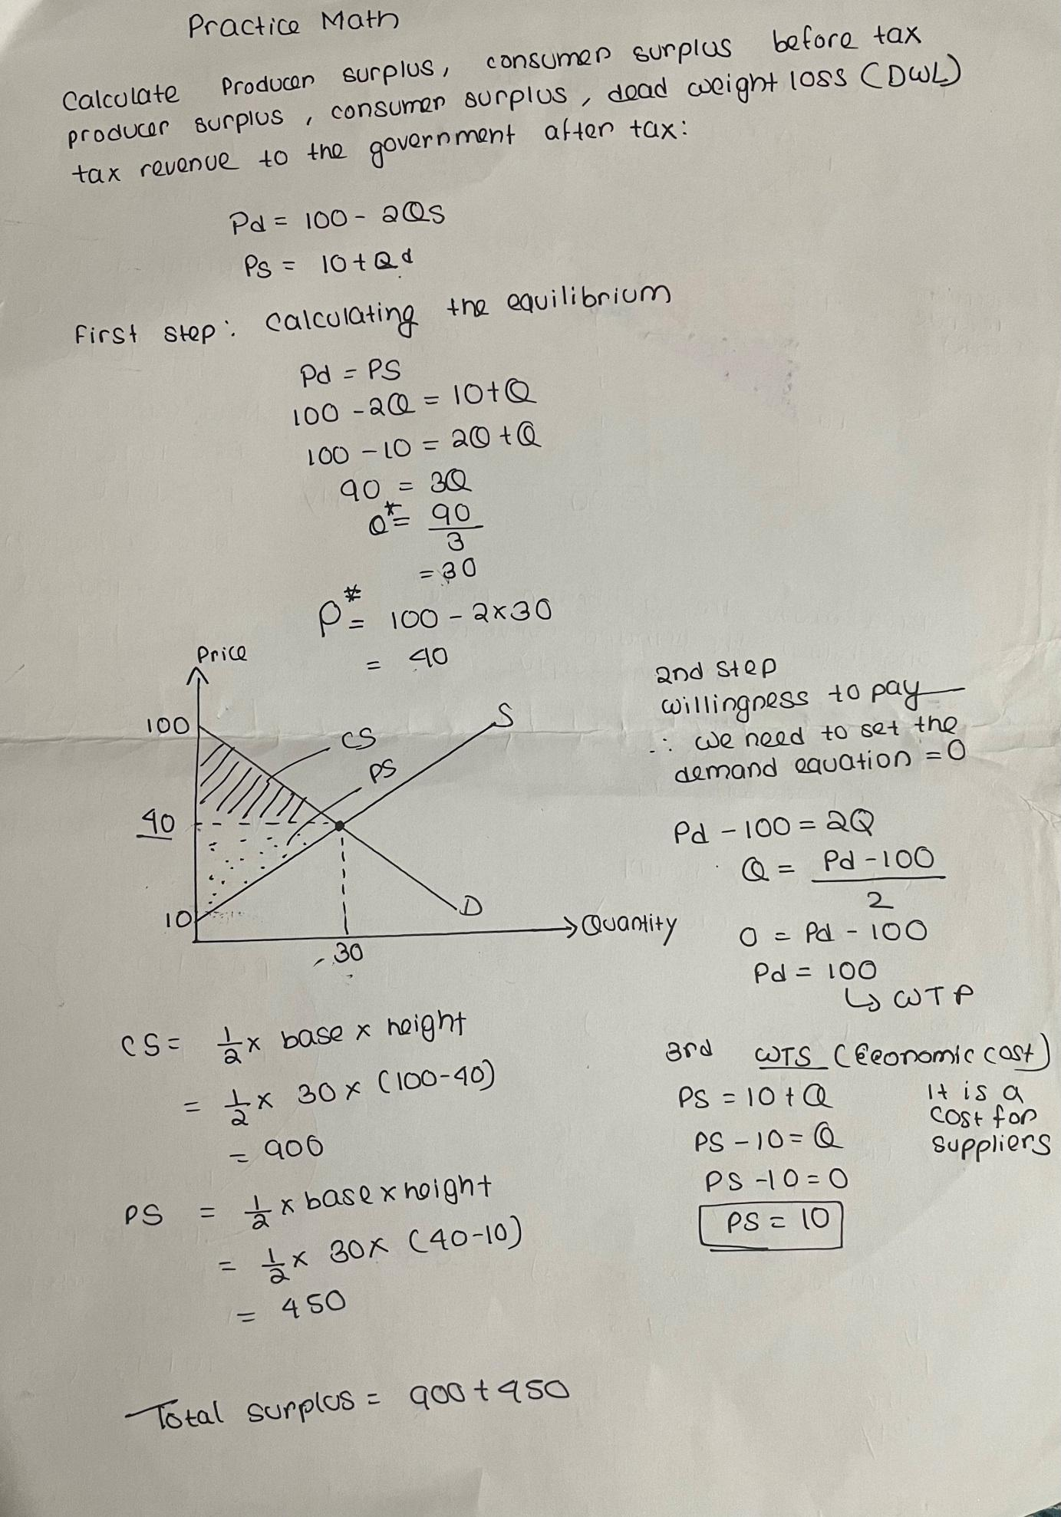

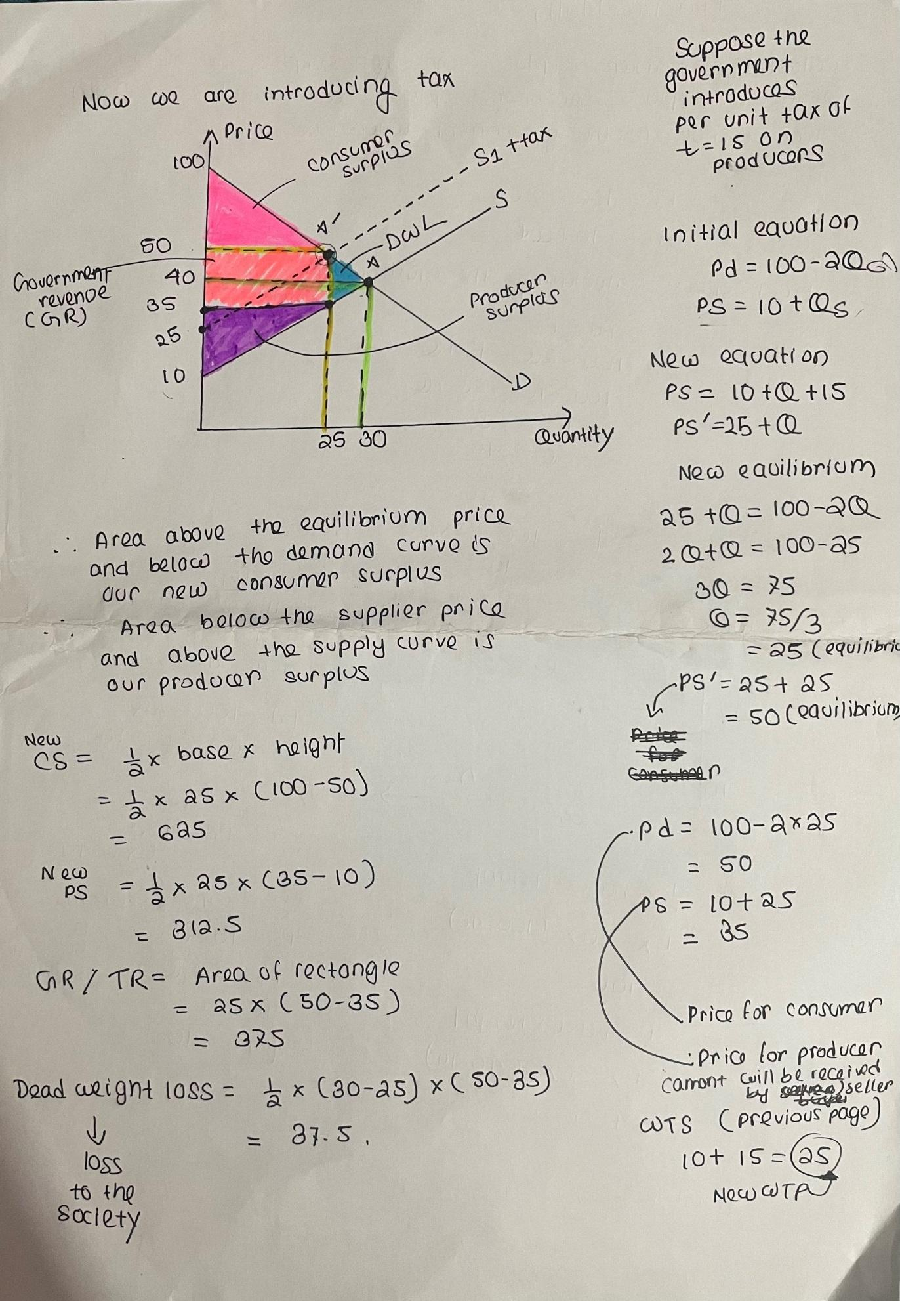

Note: *for question 4 and 5, a detailed explanation of the steps is given for your better understanding. However, in the exams, you do not need to explain the steps in detail; rather you need to only do the steps, unless otherwise stated.*

**Question 4**. Suppose that the market for milk can be represented by the following equations:

Demand: *P = 12 – 0.5QD*

Supply: *P = 0.1QS*

where P is the price per gallon, and Q represents the quantity of milk, represented in millions of gallons of milk consumed per day.

a) Calculate the equilibrium price and quantity of milk.

b) To help dairy farmers, the government sets a **minimum price of $2.50** per gallon of milk. What is the new quantity of milk sold in the marketplace?

c) Illustrate your answers to (a) and (b) on a graph. Using this graph, calculate how the consumer surplus and producer surplus change **after** the price supports are enacted. Also calculate any deadweight loss that results.

d) Suppose that the government supports the $2.50 per gallon price by purchasing any excess milk suppliers make available but are unable to sell to consumers. How much milk must the government buy?

**Solution:**

a) The equilibrium occurs where supply equals demand:

12 – 0.5Q = 0.1Q

0.6Q = 12

Q = 12/0.6

Q = 20 million gallons

To find the price, we substitute the equilibrium quantity into either the demand or supply equation:

Either: P = 0.1(20) = $2

Or: P = 12 – 0.5(20) = $2

b) The minimum price is above the equilibrium price. Thus, there will be an excess supply of milk – more people will want to sell milk than will be willing to buy milk. The new quantity sold will be limited by the number of people willing to purchase milk at this higher price. We find this by substituting $2.50 for P in the demand equation, and then solving for Q:

2.50 = 12 – 0.5Q

9.50 = 0.5Q

Q = 9.50/0.5

Q = 19 million gallons

c) To draw the graph, we begin by drawing the supply and demand curves. Note that the equations are already solved for P. Thus, we know that the y-intercept (on the price axis) for demand is $12. Similarly, by setting P = 0, we find that Q = 24 when P = 0 (because 12 – 0.5(24) = 0).

For supply, we know the line goes through the origin (y-intercept = 0), and intersects demand at a quantity of 20 and a price of $2.

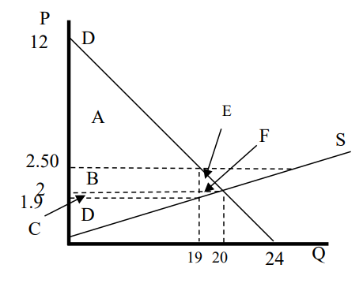

With a price floor of $2.50, note that there will be excess supply, so the quantity demanded at $2.50 determines the quantity sold. As we found in part (b), this is 19 million gallons of milk.

Consumer surplus is everything above the price and below the demand curve. Before the price supports are enacted, this is areas A, B and E above. This is a triangle with a base of 20 and a height of 10 (=12-2). Thus, the area of this triangle, and thus the consumer surplus, equals 0.5(20)(10) = $100.

After the price supports are in place, consumer surplus falls to just area A. This is a triangle with a base of 19 and a height of 9.5 (=12-2.5). Thus, the area of this triangle = 0.5(19)(9.5) = $90.25.

Producer surplus is everything below the price and above the supply curve. Without price supports, this is areas C, D, and F. The area of this triangle = 0.5(20)(2) = $20.

With price supports, producer surplus is areas B, C, and D. Thus, producers lose F, but gain B. Area B is a rectangle with a height of 0.5 (=2.50 – 2) and a base of 19. Its area = (0.5)(19) = 9.5. To find the areas for C and D, we need to know where the line between these areas hits the supply curve at the quantity of 19. We get this by substituting 19 for Q in the supply equation: P = 0.1(19) = 1.9. Given this, we can now calculate that rectangle C has an area of 1.9 (=0.1x19), and triangle D has an area of 18.05 (=0.5x19x1.9). Thus, the total producer surplus = 9.5 + 1.9 + 18.05 = $29.45. As expected, producer surplus increases, and consumer surplus decreases, after price supports are enacted.

There is a deadweight loss with the price supports, because some milk that was sold before is now not sold. This is areas E and F. Note that these two areas are part of consumer or producer surplus before the price supports are in place, but not afterwards. These areas represent lost opportunities because less milk is s seeold. To calculate the value, note that this is a triangle with a height of 0.6 (= 2.5 – 1.9) and base of 1 (= 20 – 19). The area is (0.5)(0.6)(1) = $0.30.

Finally, to see the intuition of deadweight loss, compare the sum of consumer and producer surplus before and after the policy. Before the policy, the total surplus is $120. After the policy, the total of consumer and producer surplus is $119.70. The difference between these is $0.30. That is, $0.30 of potential surplus is lost because of the minimum price.

d) The excess supply is the difference between the quantity supplied at a price of $2.50 and quantity demanded at a price of $2.50. We know from part (b) that 19 million gallons are demanded at this price. Thus, we just need to find the quantity supplied at this price:

2.50 = 0.1QS

QS = 2.50/0.1

QS = 25 million gallons

Since 25 million gallons of milk are available for sale, but consumers only purchase 19 million gallons, the government must purchase the 6 million gallons that are not purchased by consumers.

**Question 5**. Norway has a sugar tax that is a tax paid on chocolate and sugar products that are either imported into Norway or produced in Norway. In 2016 the tax was around 20 Norwegian krone (NOK) per kg. Consider the market for candies in Norway before the introduction of this sugar tax. Market demand and market supply curves are given by the following equation below where P is the price in NOK per kg of candies and Q is the quantity in kg of candies:

Market Demand: P = 125 – (3/8)Q

Market Supply: P = 5 + (1/8)Q

a) Given the above information, find the equilibrium price and quantity in this market.

b) Calculate the values of consumer surplus and producer surplus before the imposition of the tax. Show them graphically in a well-labeled graph.

c) Given this excise tax of 20 Norwegian krone, find the new price consumers will pay for each kg of candies, the new price producers will receive for each kg of candies after they pay the excise tax, and the new equilibrium quantity of kg of candies that will be sold in the market. Show the impact of this excise tax in a well labeled graph.

d) Given this excise tax, calculate the value of consumer surplus with the tax, producer surplus with the tax, tax revenue the government receives from implementing the tax, and the deadweight loss due to the implementation of this excise tax. Show these areas in a well-labeled graph.

**Solution:**

(a)

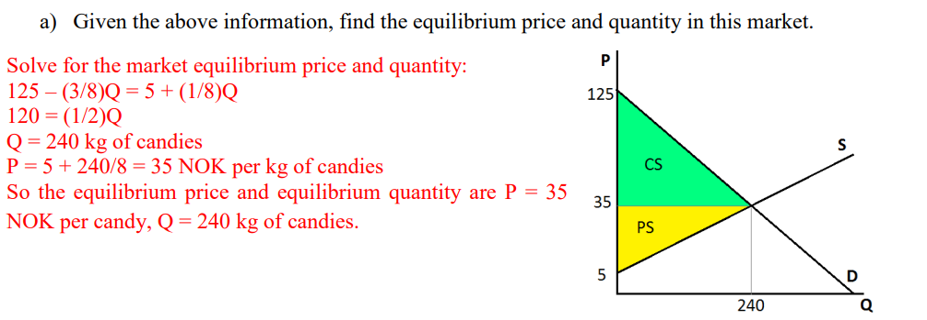

(b)

Producer surplus is (1/2)(240 - 0)(35 - 5) = 3,600 NOK

Consumer surplus is (1/2)(240 - 0)(125 - 35) = 10,800 NOK

(c) With this excise tax the supply curve shifts up by the amount of the tax per unit, because at each quantity sellers’ costs increase by the amount of the tax, i.e. 20 NOK. The new equation for the supply curve with the tax: P=5+(1/8)Q+20. Solve for the new market equilibrium price and quantity:

125 – (3/8)Q = 25 + (1/8)Q

100 = (1/2)Q

Q with the tax = 200 kg of candies

P with the tax = 125 – (3/8)*200 = 50 NOK per kg of candies. It is the price that consumers will pay.

After tax producers will receive 50 – 20 = 30 NOK per kg of candies. This is the net price with the tax.

So the equilibrium quantity with the excise tax is Q = 200 kg of candies, the price consumers pay with the tax is P = 50 NOK per kg of candies, and the price producers receive after paying the excise tax to the government is 30 NOK per kg of candies

(d) Producer surplus is (1/2)(200 - 0)(30 - 5) = 2,500 NOK

Consumer surplus is (1/2)(200 - 0)(125 - 50) = 7,500 NOK 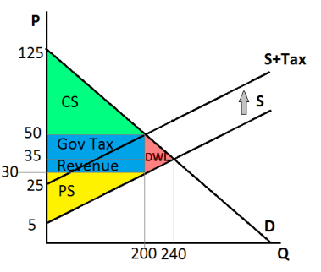

Government Tax Revenues is 20*200 = 4,000 NOK

DWL is (1/2)(240 - 200)(50 - 30) = 400 NOK